**Non-exam assessment A-level Computer Science (7517)**

**Automated Video/Photograph Facial Blurring Tool**

Anton Zhulkovskiy

Candidate Number: XXXX

Center Name: Sunmarke School

Center Number: XXXX

**Contents**

1. Analysis 3-12
2. Documented design 13-28
3. Technical solution 29-42
4. Testing 43-47
5. Evaluation 48-50

**Analysis**

**Project Problem Definition**

Client: Sunmarke School Marketing department

Name

Contact: Name

Address

**Background to the Problem**

In the United Arab Emirates recordings in public areas which are later shared online through social media and live television require all unpermitted identities to be hidden as it is illegal to show a person’s face without their permission and could result in large fines or even jail time. The solution most Youtubers, Marketing teams, celebrities and news companies have is manually blurring the faces using typical video editing software.

The current solution that the Sunmarke Marketing department has that prevents them from invading a person’s privacy is to only publicize photos and videos from planned photoshoots with permission from all people in the video. Any unplanned recordings or photos taken by the department requires the editing team to manually blur out faces of people who did not give their permission to be recorded.

**Interview with head of Marketing at Sunmarke School (Primary research)**

Q: What do you know about the UAE’s regulations in regards to invading a person’s privacy without their permission?

A: As we are working in the marketing department, we have to always make sure that our team is up to date with any laws regarding privacy when filming or taking photos. I am aware that it is illegal to record a person without their permission and doing so would lead to huge fines.

Q: How does Sunmarke currently avoid invading privacy when creating social media posts and advertisements?

A: We usually chose to film advertisements inside the school or in areas with no people other than the ones taking part in the creation of the video or photoshoot. Although for our social media posts we email the parents of students to get permission for their children to get posted or just blur out the faces of people who did not provide their permission to be recorded.

Q: Is there any particular software that is used to blur out faces of people who did not give permission to be recorded or photographed?

A: Our editing team uses Photoshop for blurring the faces in images and for videos they either use YouTube Studio’s tool or an external tool for Premier Pro.

Q: Would you be interested in a program which could automatically blur out faces that are visible in videos and photos?

A: That could potentially save time for the editors but I would first like to see it as it will have to work accurately to prevent Sunmarke online publications from breaking any laws here in the UAE. Apart from that a tool which could shorten our blurring process would be very helpful.

Q: On average how long are the video advertisements or publications in Sunmarke?

A: The video publications are usually no longer than 30 seconds.

Q: What form are most of your advertisements/social media publications in? Photographs or Videos?

A: Sunmarke posts a mixture of videos and photographs so I would say that it is probably quite equally distributed.

**Observation of Existing Systems (Secondary Research)**

I started by researching existing methods of blurring faces on videos before uploading them to social media. The Sunmarke Marketing department have told me that they make use of a facial blurring tool available in YouTube Studio Editor for videos and manually blur pixels on photoshop for pictures.

YouTube blurring tool process:

* Import your video into YouTube Editor.
* Select automatic facial blurring or manually blur objects.
* If manual blurring selected, using blur tool, blur out required areas on video and choose the duration of the blurring.
* Finally, video is rendered with blurring effects added to it.

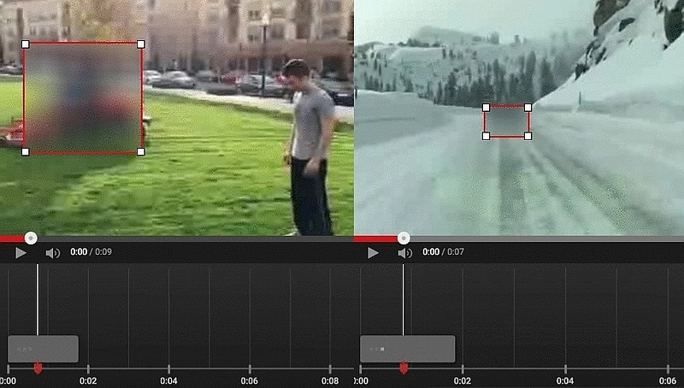

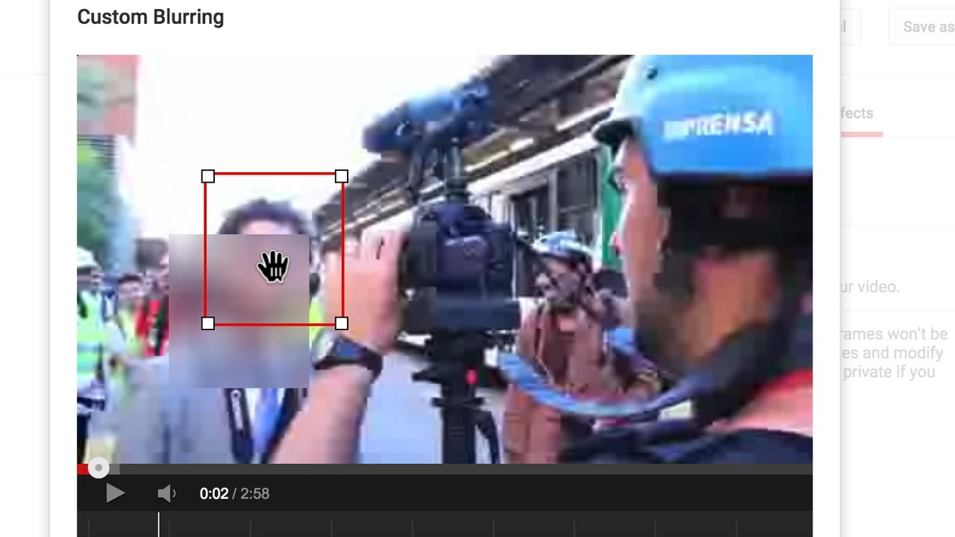

Photoshop blurring tool process:

* On Photoshop use the selection tool to select faces one-by-one
* Open up the filter menu > select blur > select Gaussian blur
* 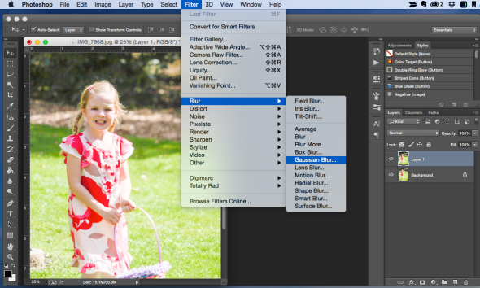Select the intensity of the blur
* Result of the Gaussian blur on photoshop would look like this

**Current System flowchart**

This flow chart represents the process videos and photographs go through in the Sunmarke marketing department to apply blurring effects. This flowchart will allow me to find ways to shorten/simplify the process and make sure my solution does not have the inefficiencies the current system shows.

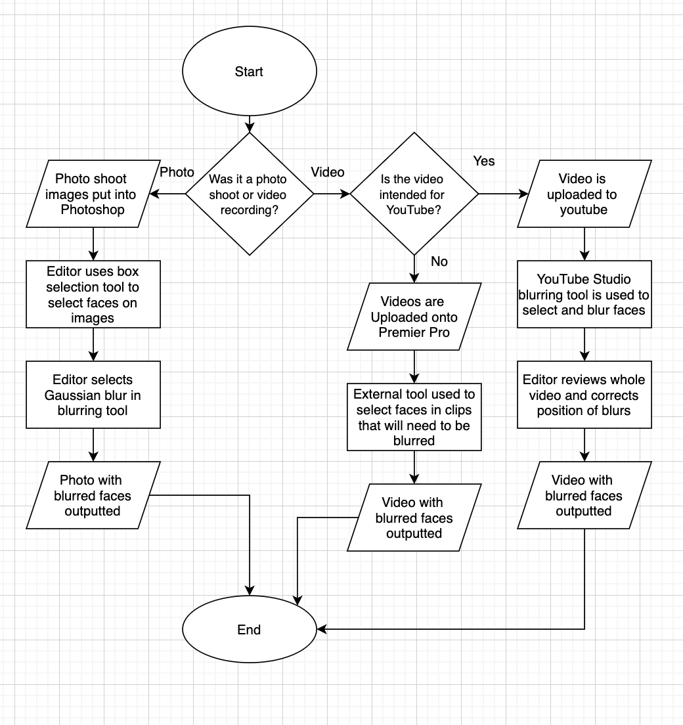

**Limitations to current systems (Secondary Research)**

As the flowchart shows the current system splits the process of blurring faces into 3 parts depending on whether the product is an image or video and on where the product will be uploaded. For YouTube videos, YouTube Studio’s blurring tool is used, for photographs Photoshop is used and for other videos an external tool in Premier Pro is used.

Overall limitations:

* Different software being used for YouTube videos and other videos as well as photographs.
* More people take part in the process as each editor specializes in their own software

Photoshop limitations:

* Requires editor to select faces one by one. Some tools allow for quick selections but this may result in the blurring of more than just the face.

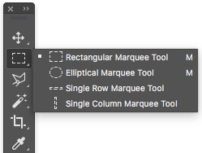

Premier Pro limitations:

* External tool required to be downloaded and set-up for blurring faces
* Inaccurate automated blurring, movement in videos often causes face to be visible
* Requires manual adjustment frame by frame of video
* Process is time consuming as editor has to check each frame for blurring accuracy

YouTube Studio Limitations:

* Most easy to use and accurate software but sometimes has errors in automatic face tracking requiring adjustments
* Only large downside is that the tool is only compatible for videos that are uploaded to YouTube.

**Objectives for the Proposed System**

For the past couple of weeks, I have conducted primary and secondary research into previously existing systems for blurring faces in videos and images. I was able to identify which features work well in different software and the drawbacks of the types of software when it comes to blurring faces and tracking faces for a moving blur.

1. The system has to have two sections:
   1. Photographs
   2. Videos
2. A system has to be set in place for user to Input their photograph or video
3. User should be able to input pictures of faces they would like avoided in the blurring process
4. System must be put into place to adjust the strength of the blur.
5. Input section has to work quickly and has to be simple to understand
6. Every face in video/photo has to be blurred (except the inputted faces)
7. For videos, blurring has to be done frame by frame for accurate facial tracking
8. Photo blurring process should be almost instant
9. Video blurring process should be quick
10. The user should be given a preview of what the blurred video/photo will look like
11. User should be able to decide whether they are happy with the blur
12. If not, blurring process has to be restarted
13. Once successful, video or photograph should be saved
14. Output should be of the same file type as the user has inputted
15. System has to make it clear to user where final file will be saved or user has to be given the option of choosing file location.

**Potential Solutions and Justification for the Chosen Solutions:**

1. A desktop blurring tool for photographs and videos. The tool would blur everyone face in the photograph apart from the face closest to the middle on the picture of frame. The tool would have the option for a video or photo to be inputted and corresponding algorithm will be run. Output will be to same video or photo with all but central face blurred.
   1. Would be most suitable for time-frame for the non-exam assessment but is likely to be rejected by Sunmarke marketing team.
   2. Low feasibility only useful for videos and photos with one target person
   3. Would require previous system to be used for videos or photos with more than one target person
   4. Would not work if target persons face is not closest to the center
   5. Would make little to no difference in steps from previous system in most cases
   6. Would not be a worthy system for the marketing team to support my effort
2. An application which can be used to blur faces whilst record the videos or taking the pictures. This would require to be implemented into a smartphone application to be suitable for recording, the app would have options of who to blur in the scene.
   1. Would be able to achieve the final goal of blurring faces of everyone but targets
   2. Would eliminate the previously required systems (photoshop, YouTube Studio and Premier Pro)
   3. Would require Sunmarke Marketing team to use mobile devices when they require faces to be blurred which is inconvenient and can result in lower quality photos and videos. Currently they use professional cameras.
   4. Errors in the system would require videos and photographs to be retaken which could make the system more time consuming than the current one.
   5. May be difficult to create a mobile app in the given time frame as interface has to be modified for different devices.
   6. Would be an improvement from the previous solution if errors do not occur system will be able to record multiple people.

Chosen solution:

1. A desktop blurring tool for both photographs and videos. The tool would take user input of the video/photograph and photographs of multiple angles of the faces of target people in the videos/photographs. The tool would then blur all faces but the ones which were set as target people’s faces. The tool will have a preview of the result and then the photograph or video will be saved to the device with blurring affects applied.
   1. As long as all targets are achievable with my knowledge and research ability as well as in the given time frame this solution has feasibility.
   2. Solution will meet Sunmarke Marketing department requirement of accuracy as the preview tool would allow for user to ensure no faces are visible as well as rerun the tool if failed to meet requirement
   3. Would allow for professional camera use as blurring effects are applied to recorded videos and photographs solving main issue of previous solution
   4. Would get rid of many steps in current blurring system used by Sunmarke Marketing team
   5. Would not require any other software for blurring the photos or videos.
   6. Would not have any effect on requirements for photoshoots or video recordings themselves
   7. Would be simple to use, Marketing team editors would not require to be trained to use the software as they would be able to understand how it works in minutes.

**Document Design**

Data chart outlining the flow of data in the new system that I am planning to create

**IOPS Chart**

|  |  |
| --- | --- |
| Input   * Video file to be blurred * Photograph file to be blurred * Photographs of face/s that should be disregarded in blurring effect (4 different angles) | Process   * Search for faces in image or frames of video * Compares all faces to the face to be ignored * Blurs all other faces * Shows a preview of the video/photo with faces blurred * Once confirmed, outputs video/photo with blurring effects applied |
| Storage   * Select video or photograph to be edited in file system * Store edited video/photograph preview in buffer storage file * Output video/photograph with blurring affect applied to user selected file path * Database to store the faces to not blur for the user. | Output   * Video or photograph with blurring effects applied on all faces apart from the disregarded faces |

**Flowchart of proposed system**

This flowchart is a model of the steps required in the process of blurring photos and images using my program. It shows an improvement over the current system through the reduced number of steps.

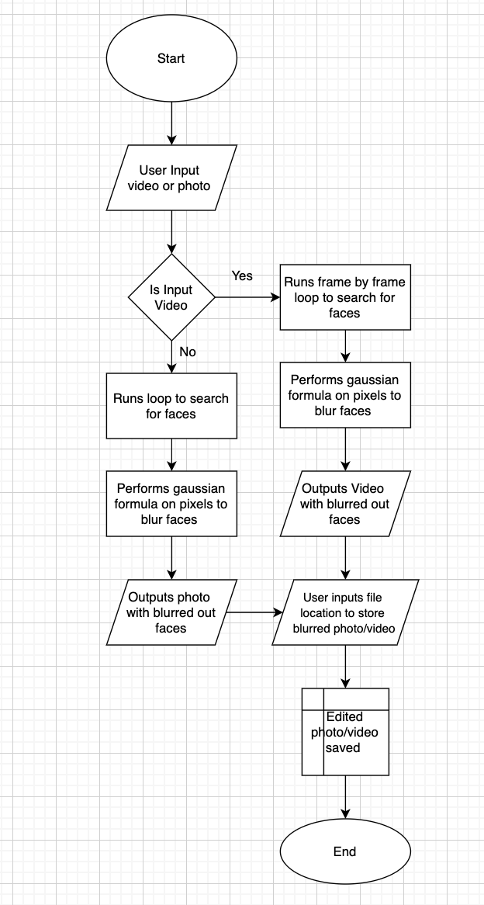

**Data Dictionary and Validation**

The table below shows all the data that users will be inputting and the validation these inputs will be going through.

|  |  |  |  |  |  |  |
| --- | --- | --- | --- | --- | --- | --- |
| Field | Data Type | Length/Size | Validation Check | Validation description | Valid Data | Erroneous Data |
| File type selection | Boolean | N/A | Button selected | One of two buttons has to be clicked on | Selects either photo or video option | Does not select option and attempts to continue |
| Video to be blurred | Video | 0-120 seconds, 0-1 gigabytes | File Type | Ensures file type can contain video content | MP4 file or WAV file | Any other file type |
| Photograph for blurring | Image | 0-5 megabytes | File Type | Checks if file type can contain an image | File type must me JPEG or PNG | Any other file type |

**User Interface Design:**

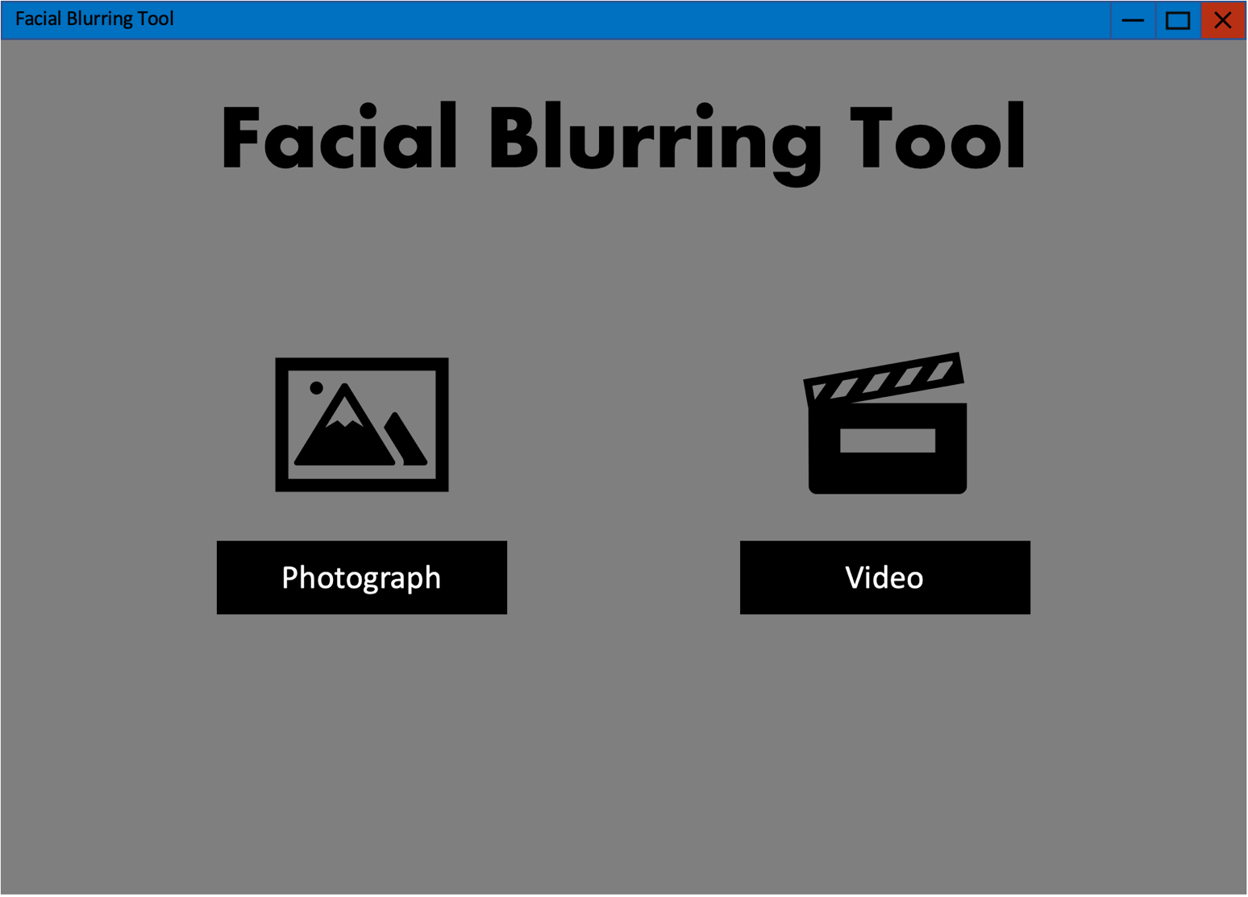

When the program is run, a main menu appears with a title and two buttons; Photograph and Video. The user would pick either video or photograph depending on the file type that they are planning to apply facial blurring to.

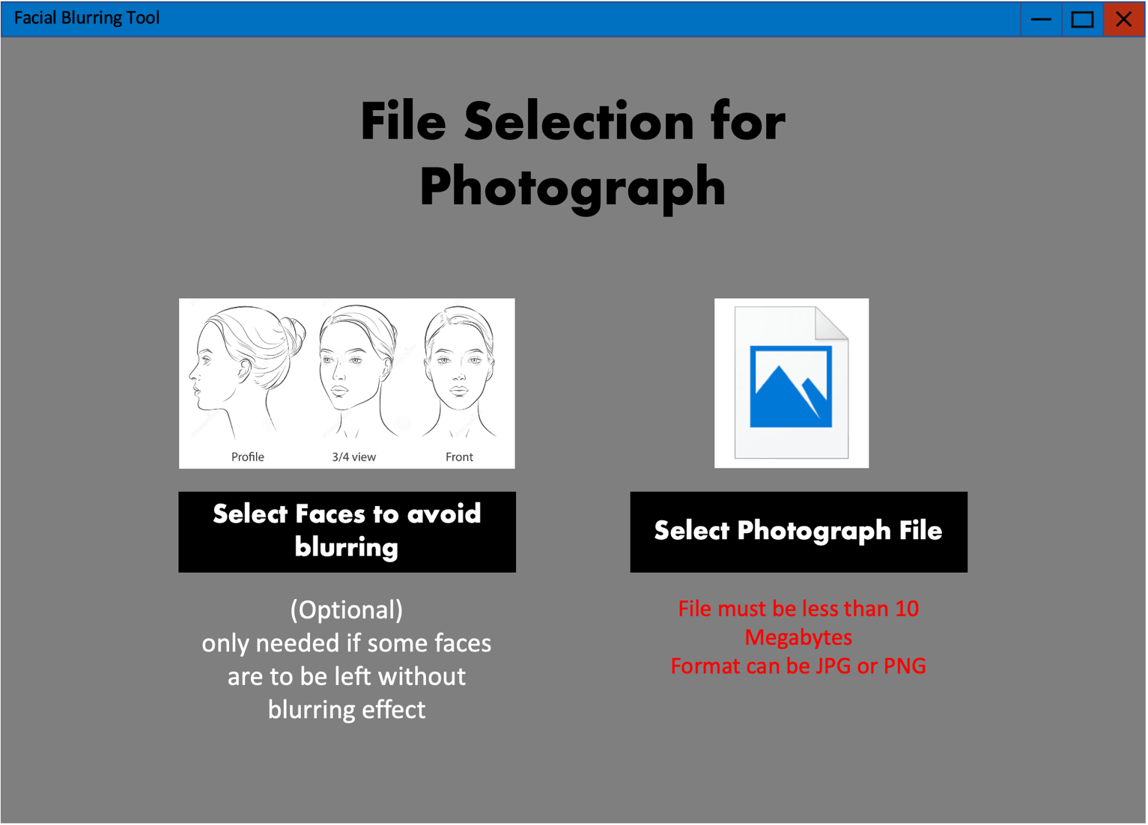

If the photograph button is pressed on the main menu the user will be taken to this screen, they will be given the option of uploading pictures of the face they would not want blurred at all different angles. Also, they will be able to upload the photograph they want the blurring effect applied to.

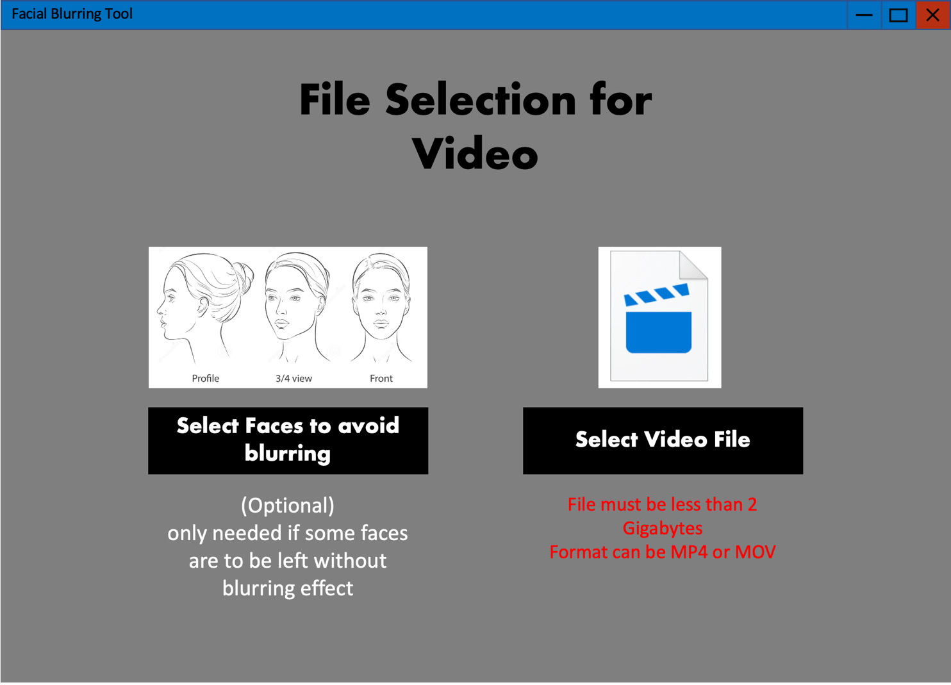

If the Video button is pressed on the main menu the user will be taken to this screen, they will be given the option of uploading pictures of the face they would not want blurred at all different angles, same as the photograph. But, this time the second option is for uploading the video they would like the blurring effect applied to instead of a photograph.

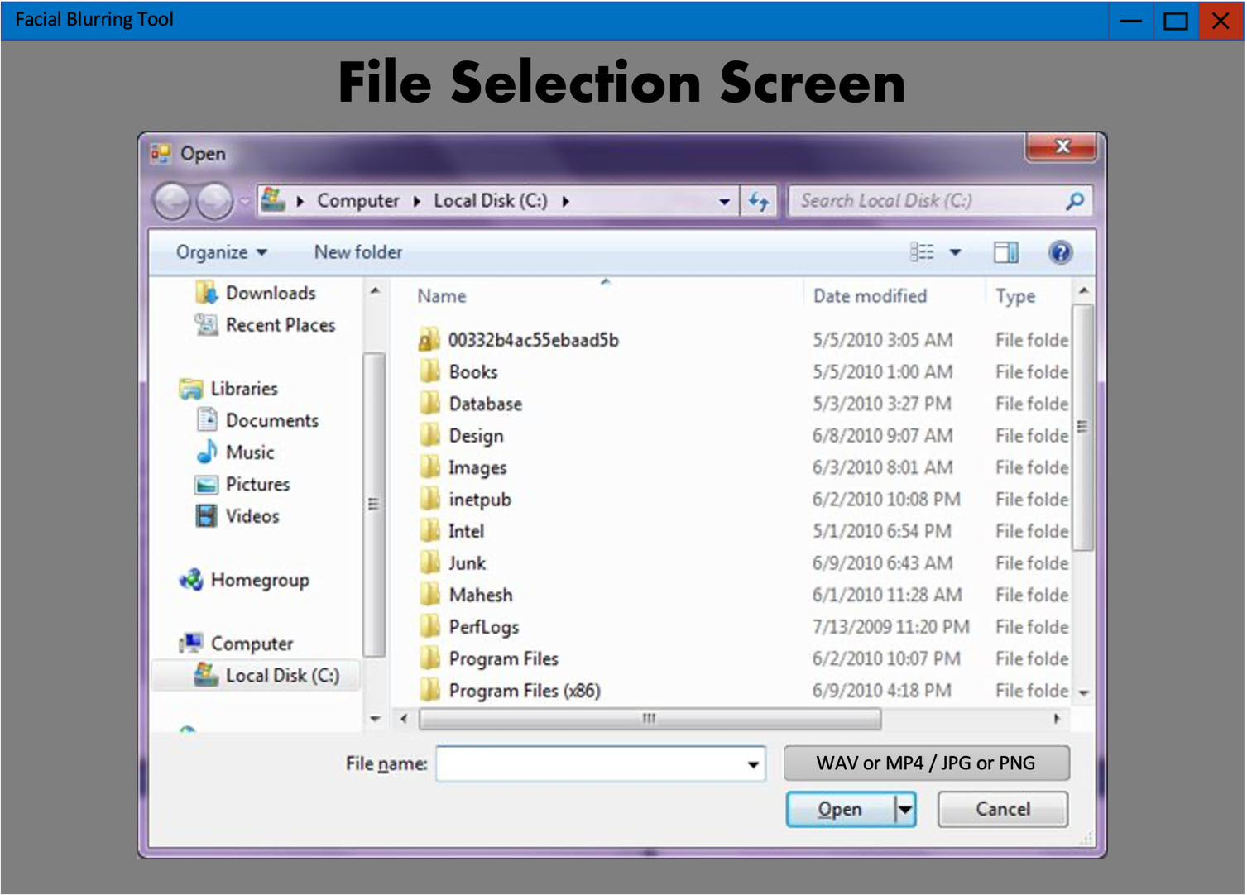

For photographs, videos and faces to avoid blurring buttons, user will be taken to this file selection screen where they can use their file explorer to select the desired file/files. The formats acceptable will be listed and there will be a confirmation if files were recognized as selected successfully.

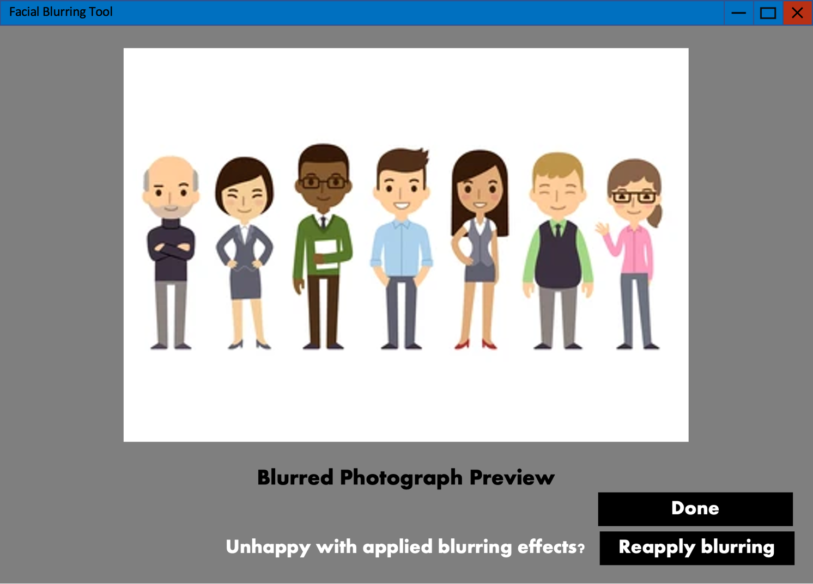

For the photograph option, once files are successfully uploaded, all blurring effects will automatically be applied to the photograph. Once all faces have been blurred, a preview of the photograph will appear on the screen. There will be a done button if the user is happy with blurring effects applied and a reapply button incase the program bugged out and failed to blur some faces in which case blurring will be applied all over again.

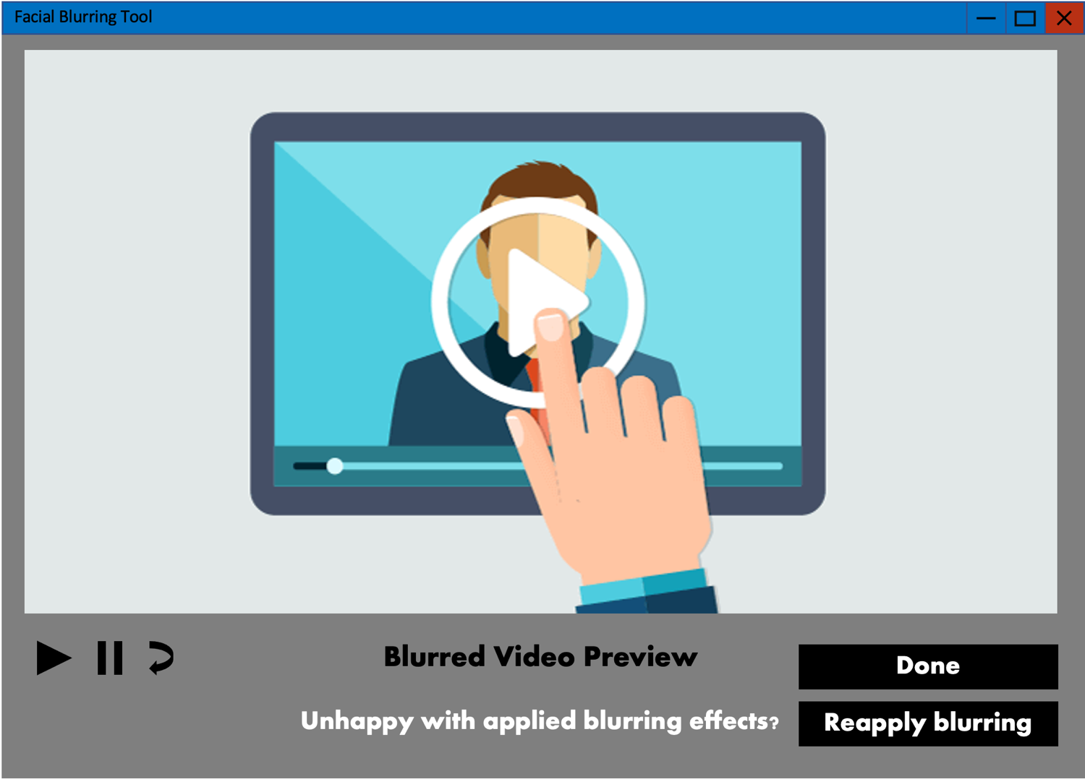

For the video option, once files are successfully uploaded, all blurring effects will automatically be applied to the video. Once all faces have been blurred, a preview of the video will appear on the screen with the option to play, pause and restart the preview. There will be a done button if the user is happy with blurring effects applied and a reapply button incase the program bugged out and failed to blur some faces in which case blurring will be applied all over again.

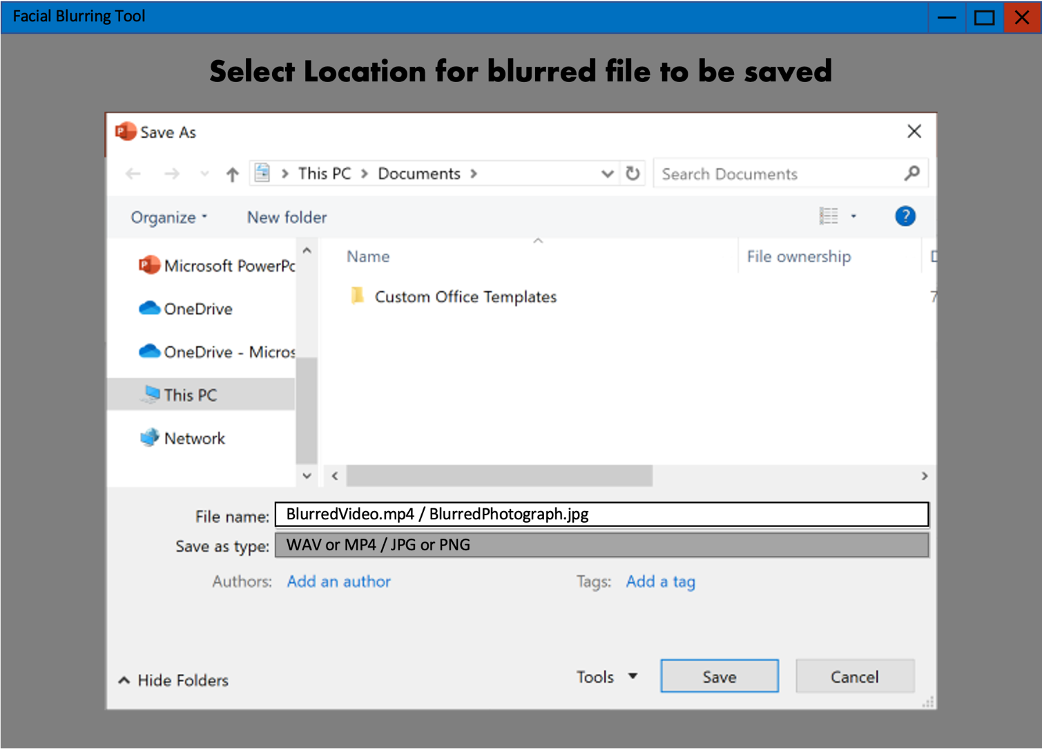

Once done button is pressed, file explorer will be opened again, the user will be prompted to select a location on their computer to store the video/photograph with the blurring effects applied to them. Once save is pressed, the video/photograph will be saved in the same file format as its original form.

**Database Normalization and design**

**Bold** means primary key and *italic* mean foreign key.

**tblUsers**

|  |  |  |
| --- | --- | --- |
| **UserID** (int) | Login (Char) | Password (Char) |
|  |  |  |

**tblImages**

|  |  |  |
| --- | --- | --- |
| **ImageID** (int) | *UserID* (int) | Image (BLOB) |
|  |  |  |

The table is already in third normal form allowing for quick access using the USER_ID. With the User_ID as the foreign key in tblImages each user login will allow access to all the images under their User_ID. These Images will be the faces the user has chosen to save on the database for future use so that these faces do not get blurred in the future.

**Simple database relationship Diagram**

tblImages (ImageID, UserID, Images)

tblUsers (UserID, Login, Password)

**Possible SQL queries**

|  |
| --- |
| Create table users |
| “CREATE TABLE IF NOT EXISTS Users (UserID INTEGER NOT NULL PRIMARY KEY, username CHAR(40), password CHAR(40)” |

|  |
| --- |
| Create table images |
| “CREATE TABLE IF NOT EXISTS Images (ImageID INTERGER NOT NULL PRIMARY KEY, UserID INTEGER NOT NULL, Images MEDIUMBLOB NOT NULL, FOREIGN KEY(UserID) REFERENCES Users.UserID)” |

|  |
| --- |
| Add user to tblUsers |
| * |

|  |
| --- |
| Add faces to users Images (current user is the ID of the logged in user and binary data is the binary data of the face image) |
| f“INSERT INTO Images (UserID, face)  VALUES ({CurrentUser},{binarydata}) “ |

|  |
| --- |
| Retrieve faces from table images to stop them from being blurred |
| f“SELECT face  FROM Images  WHERE UserID = {currentuser}” |

**OOP Class design**

The main program will consist of several object with each object having the attributes to make up all the items in the GUI. The main Object will consist of methods for file handling and bringing each frame (page) of the GUI to the front when the corresponding button is selected.

|  |
| --- |
| class Blurring (): |
| Faces list (stores file locations of face images to prevent them from blurring)  Main images string (stores the file location of the main image selected by user)  frames tuple (stores all the frames of the tkinter GUI, each frame was shown above in the user interface design section) |

|  |
| --- |
| Class MainMenu(): |
| Contains object for UI as attributes with no methods |

|  |
| --- |
| Class PagePhoto(): |
| Contains object for UI as attributes with no methods |

|  |
| --- |
| Class PageVideo(): |
| Contains object for UI as attributes with no methods |

|  |
| --- |
| Class PhotoPreview(): |
| Contain UI objects as attributes  Method to load blurred image allowing user to preview their final blurred image |

|  |
| --- |
| Class VideoPreview(): |
| Contain UI objects as attributes  Method to load blurred video allowing user to preview their final blurred video |

**File Structure and Organization:**



**GUI**:

Folder stores all the images and files required for building up the GUI pages for functionality and helping the user understand how to use the application.

**ignore:**

Temporary storage, folder will store images of all users, uploaded faces to avoid in the blurring process. Will also automatically retrieve all saved face images from user’s image table in database faces.bd.

**main**:

Temporary storage, folder for storing the Image file or video file that the blurring will be applied to.

**temp:**

Central folder for the blurring process, will store images of all detected faces in the image, once blurring algorithm is applied blurred face images will be stored here too then pasted onto the main image or video. Once all blurring is applied final file will be stored here until user saves the file or reruns the program. After the program has complete running all items in the temp folder will be cleared for use when program is run again.

**faces.db:**

Database that will store usernames and passwords for each user created. There will be a table to store face images for future use. Users who save their faces will be able to blur images without uploading face images again as the database faces will not get blurred again.

**Algorithm design:**

|  |
| --- |
| **Explanation GUI** |
| Tkinter implementation of frames using a list of different frames to represent each stage in the user interface. Each frame will contain buttons to navigate through the blurring process, text and images will guide the users to understand how to program functions. |
| **Pseudo-code** |
| Frames = [main-menu, video, photo, save]  main-menu.tkraise()  IF VIDEO-BUTTON == 1 then  video.tkraise()  ELIF PHOTO-BUTTON == 1 then  photo.tkraise()  ELIF SAVE-BUTTON == 1 then  save.tkraise()  ELSE:  main-menu.tkraise()  ENDIF  # each page will contain images, buttons and text for user guidance  button = tk.button()  button.place()  image = tk.image()  image.place()  text = tk.bodytext()  text.place() |

|  |
| --- |
| **Explanation facial detection** |
| An algorithm will be put into place to detect faces in the main image and detect faces in the images uploaded to be avoided. These images will be stores in lists, one will contain all the faces in the main image and the other will contain all the faces to avoid in blurring process. These faces are stored as encodings which can be compared to see if faces match up, if they do then the corresponding match will not get blurred. |
| **Pseudo-code** |
| Main-faces=[(face, location-on-image)]  Avoid-faces=[]  For i in (Avoid-faces) do  If i in main-faces do  main-faces(index(i)).pop()  for x in main-faces do  y= blur(x)  paste y on main-image at location-on-image |

|  |
| --- |
| **Explanation blurring algorithm** |
| A mathematical equation will be used to make an algorithm loop through the image traversing through the red, blue and green values of the image to calculate average colour values to apply blurring effect. Each pixel on the face will be given a weighting ensuring that the face structure is maintained even when blur is strong enough to make facial features unidentifiable.  GAUSSIAN FUNCTION IN USE:  Diagram, venn diagram  Description automatically generated  Resultant shape of weightings given to the pixel color averages:  Chart, surface chart  Description automatically generated |
| **Pseudo-code** |
| Read file image im rb  Image = [[[x,y,r,g,b]]]    Equation = g(x) # from above  For x in range image width do  For y in range image height do  One =G(image(x,y,r))  Two = G(image(x,y,g))  Three = G(image(x,y,b))  Image[x,y] += [one, two, three]  Paste Image onto main-faces at location-on-image |

**Technical solution:**

**Main program, using object-oriented program importing subroutines from separate programs to find faces, access SQLite3 database and apply blurring:**

import tkinter as tk  
from PIL import ImageTk, Image  
from tkinter import filedialog, messagebox, IntVar, ttk  
import os  
import shutil  
# import cv2  
# from tkVideoPlayer import TkinterVideo  
# import datetime  
from SQL_faces import insert_images, retrieve_images, cleartable  
from face_rec import facelocatephoto, facelocatevideo, deletefiles, savefile  
  
# Fonts  
TITLE_FONT = ("Fixedsys", 100, "bold")  
TITLE_FONT_2 = ("Fixedsys", 80, "bold")  
SUBTITLE_FONT = ("Fixedsys", 24, "bold")  
BODY_FONT = ("Verdana", 14)  
  
  
# master class to control which screen GUI shows and file handling  
class BlurringTool(tk.Tk):  
 def __init__(self, *args, **kwargs):  
   
 # calls the Tk library to use OOP for frames in GUI  
 tk.Tk.__init__(self, *args, **kwargs)  
   
 # list stores file locations of images of faces to not be blurred  
 self.faces = []  
   
 # file location of file to be blurred image or video  
 self.file = ""  
 tk.Tk.wm_title(self, "Face Blurring Tool")  
 screen = tk.Frame(self)  
 screen.pack(side="top", fill="both", expand=True)  
 screen.grid_rowconfigure(0, weight=1)  
 screen.grid_columnconfigure(0, weight=1)  
   
 # tuple stores the frames of the GUI  
 self.frames = {}  
   
 # loop to flip through every frame in TkInter, each child object represents a frame and every function within it  
 for i in (MainMenu, PageVideo, PagePhoto, VideoPreview, PhotoPreview):  
 frame = i(screen, self)  
 self.frames[i] = frame  
 frame.grid(row=0, column=0, sticky="nsew")  
 self.show_frame(MainMenu)  
 self.resizable(False, False)  
  
 # function to bring selected frame to top  
 def show_frame(self, cont):  
 frame = self.frames[cont]  
 frame.tkraise()  
  
 # function to select and move store images of faces to avoid  
 def avoid_file(self, save):  
 self.faces = filedialog.askopenfilenames()  
 for i in self.faces:  
   
 # file error handling, incase incorrect file type is selected error message will be shown  
 while not i.endswith((".jpg", "jpeg", "png")) and i is not False:  
 messagebox.showinfo("File Type Error", "Please only upload JPG or PNG")  
 self.faces = filedialog.askopenfilenames()  
   
 # if save faces on database checkbox is ticked, the face images uploaded will be saved for future use  
 if save == 1:  
 insert_images(self.faces)  
 else:  
 for x in self.faces:  
 avoidfile = Image.open(r"{}".format(x))  
 avoidfile = avoidfile.convert("RGB")  
 avoidfile.save(r"./ignore/{}.jpg".format(self.faces.index(x)))  
  
 # function to retrieve and save photo or video file to be blurred depending on the user selection  
 def main_file(self, form):  
 retrieve_images()  
 if form == "video":  
 self.file = filedialog.askopenfilename()  
 while not self.file.endswith(".mp4") and not self.file == "":  
 messagebox.showinfo("File Type Error", "Please only upload MP4")  
 self.file = filedialog.askopenfilename()  
   
 # video saved to main folder temporarily while program is run  
 shutil.copy(self.file, "./main/main.mp4")  
 else:  
 self.file = filedialog.askopenfilename()  
 while not self.file.endswith((".jpg", ".png", "jpeg")) and not self.file == "":  
 messagebox.showinfo("File Type Error", "Please only upload PNG, JPG OR JPEG")  
 self.file = filedialog.askopenfilename()  
 imagefile = Image.open(r"{}".format(self.file))  
 imagefile = imagefile.convert("RGB")  
   
 # image saved to main folder temporarily while program is run  
 imagefile.save(r"./main/main.jpg")  
  
  
# object for the main menu page of the UI  
class MainMenu(tk.Frame):  
 def __init__(self, parent, controller):  
 # inherits from parent class (BlurringTool) to allow for frames to be brought to front of users screen  
 tk.Frame.__init__(self, parent)  
  
 # section to place all Tkinter objects onto the main menu frame  
 title = tk.Label(self, text="Face Blurring Tool", fg="#584689", font=TITLE_FONT)  
 title.place(anchor="center", relx=0.5, rely=0.2)  
  
 # button to get to video file selection page  
 button_video = tk.Button(self, text="Video Blurring", fg="#584689", font=SUBTITLE_FONT,  
 command=lambda: controller.show_frame(PageVideo))  
 button_video.place(anchor="center", relx=0.25, rely=0.75, relwidth=0.4, relheight=0.1)  
  
 # button to get to photo file selection page  
 button_photo = tk.Button(self, text="Photo Blurring", fg="#584689", font=SUBTITLE_FONT,  
 command=lambda: controller.show_frame(PagePhoto))  
 button_photo.place(anchor="center", relx=0.75, rely=0.75, relwidth=0.4, relheight=0.1)  
  
 camerapath = Image.open("./GUI/camera.png")  
 cameraimage = ImageTk.PhotoImage(camerapath)  
 camera = tk.Label(self, image=cameraimage)  
 camera.photo = cameraimage  
 camera.place(anchor="center", relx=0.75, rely=0.5)  
  
 videopath = Image.open("./GUI/video.png")  
 videoimage = ImageTk.PhotoImage(videopath)  
 video = tk.Label(self, image=videoimage)  
 video.photo = videoimage  
 video.place(anchor="center", relx=0.25, rely=0.5)  
  
  
# object for video file selection page of the UI  
class PageVideo(tk.Frame):  
  
 # inherits from parent class (BlurringTool) to allow for frames to be brought to front of users screen  
 def __init__(self, parent, controller):  
 tk.Frame.__init__(self, parent)  
   
 # Variable stores the value of blurring strenght user selects on drag bar  
 self.saveface = IntVar()  
   
 # section for placing objects onto the frame on the GUI  
 header = tk.Label(self, text="File Selection for Video", fg="#584689", font=TITLE_FONT_2)  
 header.place(anchor="center", relx=0.5, rely=0.2)  
   
 # button sends back to main menu  
 button_back = tk.Button(self, text="Back to Main Menu", fg="#584689", font=BODY_FONT,  
 command=lambda: controller.show_frame(MainMenu))  
 button_back.place(anchor="center", relx=0.5, rely=0.05, relwidth=0.2, relheight=0.05)  
   
 # button calls the method in parent class to allow user to select main video file  
 button_selectvideo = tk.Button(self, text="Upload Video", fg="#584689", font=SUBTITLE_FONT,  
 command=lambda: BlurringTool.main_file(parent, "video"))  
 button_selectvideo.place(anchor="center", relx=0.25, rely=0.75, relwidth=0.4, relheight=0.1)  
   
 # button calls method in parent class to allow user to select face photos to avoid in blurring  
 button_selectface = tk.Button(self, text="Upload Faces to Avoid", fg="#584689", font=SUBTITLE_FONT,  
 command=lambda: BlurringTool.avoid_file(parent, self.saveface))  
 button_selectface.place(anchor="center", relx=0.75, rely=0.75, relwidth=0.4, relheight=0.1)  
   
 # check box, if ticked face photo uploaded will be saved to database faces.db  
 save_checkbox = tk.Checkbutton(self, text="check to save faces for future use", font=SUBTITLE_FONT,  
 variable=self.saveface, onvalue=1, offvalue=0)  
 save_checkbox.place(anchor="center", relx=0.71, rely=0.85)  
  
 explanation = tk.Label(self, text="(OPTIONAL) Upload images of each face that\n"  
 " should be avoided in the blurring process,\n"  
 " Image should look like the one above", font=BODY_FONT)  
 explanation.place(anchor="center", relx=0.75, rely=0.93)  
   
 # When button is pressed blurring is applied to all faces in video  
 button_done = tk.Button(self, text="DONE", fg="#584689", font=BODY_FONT,  
 command=lambda: [facelocatevideo(round(self.intense.get())),  
 controller.show_frame(VideoPreview)])  
 button_done.place(anchor="center", relx=0.5, rely=0.95, relwidth=0.2, relheight=0.05)  
   
 # button deletes all face photos saved by that user in the database for future use  
 button_clear_saved = tk.Button(self, text="clear saved", fg="#584689", font=BODY_FONT,  
 command=lambda: cleartable())  
 button_clear_saved.place(anchor="center", relx=0.91, rely=0.85, relwidth=0.08, relheight=0.05)  
  
 avoidfacepath = Image.open("./GUI/faceavoid.jpg")  
 avoidfaceimage = ImageTk.PhotoImage(avoidfacepath)  
 avoidface = tk.Label(self, image=avoidfaceimage)  
 avoidface.photo = avoidfaceimage  
 avoidface.place(anchor="center", relx=0.75, rely=0.5)  
  
 videofilepath = Image.open("./GUI/videofile.png")  
 videofileimage = ImageTk.PhotoImage(videofilepath)  
 videofile = tk.Label(self, image=videofileimage)  
 videofile.photo = videofileimage  
 videofile.place(anchor="center", relx=0.25, rely=0.5)  
 # drag scale to adjust blurring intensity of faces  
 self.intense = ttk.Scale(self, from_=5, to=10, orient=tk.HORIZONTAL)  
 self.intense.set(7.5)  
 self.intense.place(anchor="center", relx=0.25, rely=0.82, relwidth=0.4)  
 intensity = tk.Label(self, text="Blurring Intensity", font=SUBTITLE_FONT)  
 intensity.place(anchor="center", relx=0.25, rely=0.87)  
 weak = tk.Label(self, text="weak", font=BODY_FONT)  
 weak.place(anchor="center", relx=0.065, rely=0.87)  
 strong = tk.Label(self, text="strong", font=BODY_FONT)  
 strong.place(anchor="center", relx=0.43, rely=0.87)  
  
  
# object for photo file selection page of the UI  
class PagePhoto(tk.Frame):  
  
 # inherits from parent class (BlurringTool) to allow for frames to be brought to front of users screen  
 def __init__(self, parent, controller):  
 tk.Frame.__init__(self, parent)  
   
 # saves the integer value of face blurring intensity set by user  
 self.saveface = IntVar()  
  
 header = tk.Label(self, text="File Selection for Photographs", fg="#584689", font=TITLE_FONT_2)  
 header.place(anchor="center", relx=0.5, rely=0.2)  
   
 # button for user to go back to menu  
 button_back = tk.Button(self, text="Back to Main Menu", fg="#584689", font=BODY_FONT,  
 command=lambda: controller.show_frame(MainMenu))  
 button_back.place(anchor="center", relx=0.5, rely=0.05, relwidth=0.2, relheight=0.05)  
   
 # button to select mail file for blurring to be applied to  
 button_selectphoto = tk.Button(self, text="Upload Photograph", fg="#584689", font=SUBTITLE_FONT,  
 command=lambda: BlurringTool.main_file(parent, "photo"))  
 button_selectphoto.place(anchor="center", relx=0.25, rely=0.75, relwidth=0.4, relheight=0.1)  
   
 # button for user to select photos of faces not to be blurred  
 button_selectface = tk.Button(self, text="Upload Faces to Avoid", fg="#584689", font=SUBTITLE_FONT,  
 command=lambda: BlurringTool.avoid_file(parent, self.saveface.get()))  
 button_selectface.place(anchor="center", relx=0.75, rely=0.75, relwidth=0.4, relheight=0.1)  
   
 # save face checkbox to save faces to avoid on database faces.db for faces not to be blurred in the future  
 save_checkbox = tk.Checkbutton(self, text="check to save faces for future use", font=SUBTITLE_FONT,  
 variable=self.saveface, onvalue=1, offvalue=0)  
 save_checkbox.place(anchor="center", relx=0.71, rely=0.85)  
  
 explanation = tk.Label(self, text="(OPTIONAL) Upload images of each face that\n"  
 " should be avoided in the blurring process,\n"  
 " Image should look like the one above", font=BODY_FONT)  
 explanation.place(anchor="center", relx=0.75, rely=0.93)  
   
 # button to apply blurring to image and go to preview page to see final image  
 button_done = tk.Button(self, text="DONE", fg="#584689", font=BODY_FONT,  
 command=lambda: [facelocatephoto(round(self.intense.get())),  
 controller.show_frame(PhotoPreview),  
 PhotoPreview.display(parent)])  
 button_done.place(anchor="center", relx=0.5, rely=0.95, relwidth=0.2, relheight=0.05)  
   
 # button to delete all of users saved faces from database.db to allow them to get blurring in images  
 button_clear_saved = tk.Button(self, text="clear saved", fg="#584689", font=BODY_FONT,  
 command=lambda: cleartable())  
 button_clear_saved.place(anchor="center", relx=0.91, rely=0.85, relwidth=0.08, relheight=0.05)  
  
 avoidfacepath = Image.open("./GUI/faceavoid.jpg")  
 avoidfaceimage = ImageTk.PhotoImage(avoidfacepath)  
 avoidface = tk.Label(self, image=avoidfaceimage)  
 avoidface.photo = avoidfaceimage  
 avoidface.place(anchor="center", relx=0.75, rely=0.5)  
  
 photofilepath = Image.open("./GUI/photofile.png")  
 photofileimage = ImageTk.PhotoImage(photofilepath)  
 photofile = tk.Label(self, image=photofileimage)  
 photofile.photo = photofileimage  
 photofile.place(anchor="center", relx=0.25, rely=0.5)  
   
 # drag bar to allow for intensity of blurring of faces to be adjusted before blurring is applied  
 self.intense = ttk.Scale(self, from_=5, to=20, orient=tk.HORIZONTAL)  
 self.intense.set(8)  
 self.intense.place(anchor="center", relx=0.25, rely=0.82, relwidth=0.4)  
 intensity = tk.Label(self, text="Blurring Intensity", font=SUBTITLE_FONT)  
 intensity.place(anchor="center", relx=0.25, rely=0.87)  
 weak = tk.Label(self, text="weak", font=BODY_FONT)  
 weak.place(anchor="center", relx=0.065, rely=0.87)  
 strong = tk.Label(self, text="strong", font=BODY_FONT)  
 strong.place(anchor="center", relx=0.43, rely=0.87)  
  
  
# object of page on UI to select save location of blurred video file and readjust blurring intensity if needed  
class VideoPreview(tk.Frame):  
 def __init__(self, parent, controller):  
 tk.Frame.__init__(self, parent)  
   
 # reblur button allows user to chose intensity and reblur the video if they are unhappy with result  
 button_reblur = tk.Button(self, text="Blur Again", fg="#584689", font=SUBTITLE_FONT,  
 command=lambda: [os.remove("./temp/finished.jpg"),  
 facelocatevideo(round(self.intense.get())),  
 controller.show_frame(PhotoPreview),  
 PhotoPreview.display(parent)])  
 button_reblur.place(anchor="center", relx=0.25, rely=0.80, relwidth=0.4, relheight=0.1)  
   
 # opens file dialog for user to chose save location of final file  
 button_complete = tk.Button(self, text="Save File and Finish", fg="#584689", font=SUBTITLE_FONT,  
 command=lambda: [savefile("video"),  
 deletefiles("final"),  
 controller.show_frame(MainMenu)])  
 button_complete.place(anchor="center", relx=0.75, rely=0.80, relwidth=0.4, relheight=0.1)  
   
 # scale to adjust intensity for re-blurring  
 self.intense = ttk.Scale(self, from_=5, to=20, orient=tk.HORIZONTAL)  
 self.intense.set(8)  
 self.intense.place(anchor="center", relx=0.25, rely=0.87, relwidth=0.4)  
 intensity = tk.Label(self, text="Blurring Intensity", font=SUBTITLE_FONT)  
 intensity.place(anchor="center", relx=0.25, rely=0.92)  
 weak = tk.Label(self, text="weak", font=BODY_FONT)  
 weak.place(anchor="center", relx=0.065, rely=0.92)  
 strong = tk.Label(self, text="strong", font=BODY_FONT)  
 strong.place(anchor="center", relx=0.43, rely=0.92)  
  
 # videoplayer = TkinterVideo(master=self, scaled=True, pre_load=False)  
 # videoplayer.place(anchor="center")  
 # videoplayer.place(anchor="center", relx=0.64, rely=0.36)  
  
  
# object of page on UI to select save location of blurred photo file and readjust blurring intensity if needed  
class PhotoPreview(tk.Frame):  
 def __init__(self, parent, controller):  
 tk.Frame.__init__(self, parent)  
   
 # button to reblur image if user is unhappy with blurred result  
 button_reblur = tk.Button(self, text="Blur Again", fg="#584689", font=SUBTITLE_FONT,  
 command=lambda: [os.remove("./temp/finished.jpg"),  
 facelocatephoto(round(self.intense.get())),  
 controller.show_frame(PhotoPreview),  
 PhotoPreview.display(parent)])  
 button_reblur.place(anchor="center", relx=0.25, rely=0.80, relwidth=0.4, relheight=0.1)  
   
 # opens file dialog for user to chose save location of final file  
 button_complete = tk.Button(self, text="Save File and Finish", fg="#584689", font=SUBTITLE_FONT,  
 command=lambda: [savefile("photo"),  
 deletefiles("final"),  
 controller.show_frame(MainMenu)])  
 button_complete.place(anchor="center", relx=0.75, rely=0.80, relwidth=0.4, relheight=0.1)  
   
 # scale to adjust intensity for re-blurring  
 self.intense = ttk.Scale(self, from_=5, to=20, orient=tk.HORIZONTAL)  
 self.intense.set(8)  
 self.intense.place(anchor="center", relx=0.25, rely=0.87, relwidth=0.4)  
 intensity = tk.Label(self, text="Blurring Intensity", font=SUBTITLE_FONT)  
 intensity.place(anchor="center", relx=0.25, rely=0.92)  
 weak = tk.Label(self, text="weak", font=BODY_FONT)  
 weak.place(anchor="center", relx=0.065, rely=0.92)  
 strong = tk.Label(self, text="strong", font=BODY_FONT)  
 strong.place(anchor="center", relx=0.43, rely=0.92)  
  
 # method to load preview of blurred image for user to decide if they want to reblur it  
 def display(self):  
 photo = Image.open("./temp/finished.jpg")  
 width, height = photo.size  
 ratio = width/height  
 photo = photo.resize((700, int(700/ratio)))  
 photoimage = ImageTk.PhotoImage(photo)  
 photopreview = tk.Label(self, image=photoimage)  
 photopreview.photo = photoimage  
 photopreview.place(anchor="center", relx=0.5, rely=0.35)  
  
  
# program section to call the master class and start the program setting window size  
if __name__ == "__main__":  
 deletefiles("start")  
 gui = BlurringTool()  
 gui.geometry("1280x720")  
 gui.mainloop()

**Program for facial recognition, comparison of faces in image and application of blurring of image:**

import face_recognition  
from PIL import Image  
import os  
import cv2  
import matlab.engine  
import shutil  
from tkinter.filedialog import asksaveasfilename  
  
  
eng = matlab.engine.start_matlab()  
  
  
# Function to detect all the faces in the main image  
def facelocatephoto(intense):  
 # List that will contain all faces that should NOT be blurred  
 ignore_face_encodings = []  
 # For loop to append all faces provided by user to be ignored into ignore face list  
 for file in os.listdir("ignore"):  
 # Only reads image files ignoring all system files  
 if not file.startswith("."):  
 known_face = face_recognition.load_image_file(f"./ignore/{file}")  
 # attempts to detect face in each image appending it to list if face is found  
 try:  
 known_face_encoding = face_recognition.face_encodings(known_face)[0]  
 ignore_face_encodings.append(known_face_encoding)  
 # Except statement to go to next image if no face is detected  
 except IndexError:  
 pass  
  
 # Load main image to find faces for blurring  
 main_image = face_recognition.load_image_file("./main/main.jpg")  
  
 # Find the coordinates of each face in the main image  
 face_locations = face_recognition.face_locations(main_image)  
 # creates encodings for the faces to later be compared with the encodings for faces to be ignored  
 face_encodings = face_recognition.face_encodings(main_image, face_locations)  
  
 # Convert to PIL format to allow image formatting and comparison of encodings  
 pil_image = Image.fromarray(main_image)  
  
 # Runs the function to blur the faces  
 blurfaces(pil_image, face_locations, face_encodings, ignore_face_encodings, int(intense))  
  
 # saves completed image in temporary file  
 pil_image.save("./temp/finished.jpg")  
  
  
def facelocatevideo(intense):  
 # List that will contain all faces that should NOT be blurred  
 ignore_face_encodings = []  
 # For loop to append all faces provided by user to be ignored into ignore face list  
 for file in os.listdir("ignore"):  
 # Only reads image files ignoring all system files  
 if not file.startswith("."):  
 known_face = face_recognition.load_image_file(f"./ignore/{file}")  
 # attempts to detect face in each image appending it to list if face is found  
 try:  
 known_face_encoding = face_recognition.face_encodings(known_face)[0]  
 ignore_face_encodings.append(known_face_encoding)  
 # Except statement to go to next image if no face is detected  
 except IndexError:  
 pass  
 video = cv2.VideoCapture("./main/main.mp4")  
  
 frame_width = int(video.get(3))  
 frame_height = int(video.get(4))  
 frame_size = (frame_width, frame_height)  
 fps = int(video.get(5))  
 output = cv2.VideoWriter('./temp/finished.mp4',  
 cv2.VideoWriter_fourcc('m', 'p', '4', 'v'), fps,  
 frame_size)  
  
 while video.isOpened():  
 out, image = video.read()  
  
 if not out:  
 break  
 image = cv2.cvtColor(image, cv2.COLOR_BGR2RGB)  
  
 # Find the coordinates of each face in the main image  
 face_locations = face_recognition.face_locations(image)  
 # creates encodings for the faces to later be compared with the encodings for faces to be ignored  
 face_encodings = face_recognition.face_encodings(image, face_locations)  
  
 # Convert to PIL format to allow image formatting and comparison of encodings  
 pil_image = Image.fromarray(image)  
  
 # Runs the function to blur the faces  
 blurfaces(pil_image, face_locations, face_encodings, ignore_face_encodings, int(intense))  
  
 pil_image.save("./temp/video.jpg")  
  
 frame = cv2.imread("./temp/video.jpg")  
  
 output.write(frame)  
  
 os.remove("./temp/video.jpg")  
  
 video.release()  
 output.release()  
  
  
# Function to blur faces  
def blurfaces(pil_image, face_locations, face_encodings, ignore_face_encodings, intense):  
 # Loop through faces in main image  
 for (top, right, bottom, left), face_encoding in zip(face_locations, face_encodings):  
 # Compare the faces detected in main image with the faces in list of faces to ignore  
 matches = face_recognition.compare_faces(ignore_face_encodings, face_encoding, tolerance=0.6)  
 # if current face does not match faces in faces to ignore list blurring is applied  
 if True not in matches:  
 # Checks to ensure face blurring algorithm does not go outside image  
 width, height = pil_image.size  
 if top < intense:  
 top = intense  
 elif bottom > height - intense:  
 bottom = height - intense  
 if left < intense:  
 left = intense  
 elif right > width - intense:  
 right = width - intense  
 face = pil_image.crop((left - intense, top - intense, right + intense, bottom + intense))  
 face.save("./temp/before.jpg")  
 name = os.path.realpath("./temp/before.jpg")   
 eng.gaussianblur(name, float(intense), nargout=0)  
 # Calls the blur function  
 blurredface = Image.open("./temp/face.jpg")  
 blurredfacefinal = blurredface.crop((intense, intense, (right - left + intense), (bottom - top + intense)))  
 # Pastes the blurred face back onto the image  
 pil_image.paste(blurredfacefinal, (left, top))  
 os.remove("./temp/face.jpg")  
 os.remove("./temp/before.jpg")  
  
  
# Function to delete files after program has been executed  
def deletefiles(pos):  
# if pos == 'final':  
# eng.quit()  
 # For loop through all images to be ignored  
 for f in os.listdir("ignore"):  
 # Ignores all system files  
 if not f.startswith("."):  
 # deletes the image file  
 os.remove(f"./ignore/{f}")  
 # Delete the main image file  
 try:  
 os.remove("./main/main.jpg")  
 os.remove("./temp/finished.jpg")  
 except FileNotFoundError:  
 try:  
 os.remove("./main/main.mp4")  
 os.remove("./temp/finished.mp4")  
 except FileNotFoundError:  
 pass  
  
# function to save final blurred file  
def savefile(filetype):  
 # file type validation, if main file is image these lines of code will execute  
 if filetype == 'photo':  
 location = asksaveasfilename(defaultextension=".jpg")  
 shutil.copy('./temp/finished.jpg', location)  
 # file type validation, if main file is a video these lines of code will execute  
 else:  
 location = asksaveasfilename(defaultextension=".mp4")  
 shutil.copy('./temp/finished.mp4', location)

**Blurring of faces algorithm, MATLAB file, using three dimensional gaussian function and manipulation of binary color data of image:**

function gaussianblur(ImgName, sz)

Img=imread(ImgName);

%Read the Image file

I = double(Img);

%Design the Gaussian Kernel using 3d gaussian function

%Standard Deviation to measure the width and height of kernel

sigma = ceil(sz/2);

[x,y]=meshgrid(-sz:sz,-sz:sz);

width = size(x,1)-1;

height = size(y,1)-1;

Equation = -(x.^2+y.^2)/(2*sigma*sigma);

Kernel= (exp(Equation)/(2*pi*sigma*sigma));

%Initialize the matrix/3darray to manipulate rgb values of image

imar=I;

%Pad the vector with zeros to ensure the blurring does not go

%outside the image causing error

I = padarray(I,[sz sz]);

%Convolution of the kernel, gaussian function applied to every

%pixel in image of the face

for i = 1:size(I,1)-width

for j = 1:size(I,2)-height

p=i+width;

q=j+height;

temp1 = I(i:p,j:q,1).*Kernel;

temp2 = I(i:p,j:q,2).*Kernel;

temp3 = I(i:p,j:q,3).*Kernel;

imar(i,j,1)=sum(temp1(:));

imar(i,j,2)=sum(temp2(:));

imar(i,j,3)=sum(temp3(:));

end

end

%Blurred image of face after Gaussian blur has been applied is saved

%into temp folder to be pasted into original image.

out = uint8(imar);

imwrite(out,'/Users/antonzhulkovskiy/Desktop/NEA/temp/face.jpg','jpg')

end

**SQL database creation and accessing program (CURRENTLY WORKING ON ADDING MORE TABLES AND HASHING ALGORITHM):**

import sqlite3  
  
# connect the local sqlite database  
MyDB = sqlite3.connect("faces.db")  
  
  
# set the cursor to access the table  
MyCursor = MyDB.cursor()  
  
  
# creates the image table in the database  
MyCursor.execute("CREATE TABLE IF NOT EXISTS Images (id INTEGER NOT NULL PRIMARY KEY, "  
 "face MEDIUMBLOB NOT NULL)")  
  
  
# inserts the images of faces uploaded by user if save checkbox is ticked  
def insert_images(filepaths):  
 for i in filepaths:  
 with open(i, "rb") as File:  
 binarydata = File.read()  
 sqlite_insert_blob_query = """ INSERT INTO Images (face) VALUES (?)"""  
 MyCursor.execute(sqlite_insert_blob_query, (binarydata, ))  
 MyDB.commit()  
  
# when a user blurs an image, all saved faces are retrieved and not blurred  
def retrieve_images():  
 sqlstatement2 = "SELECT face FROM Images"  
 MyCursor.execute(sqlstatement2)  
 result = MyCursor.fetchall()  
 for i in result:  
 image = f"./ignore/saved{result.index(i)}.jpg"  
 with open(image, "wb") as File:  
 File.write(i[0])  
 File.close()  
  
# clears all the saved faces from the database if user presses clear table button on GUI  
def cleartable():  
 delete_query = """DELETE from Images"""  
 MyCursor.execute(delete_query)  
 MyDB.commit()

**Testing:**

**GUI TESTING:**

MAIN MENU SCREEN

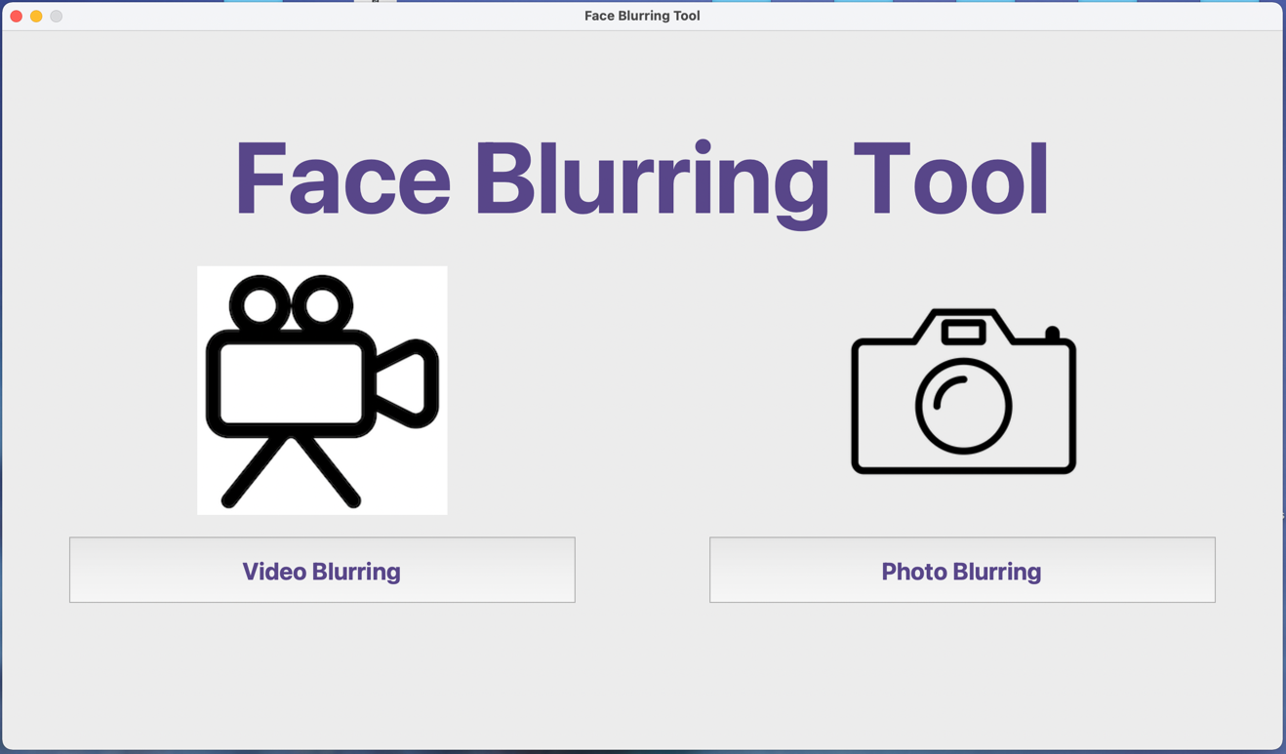

Video Blurring button pressed on main menu

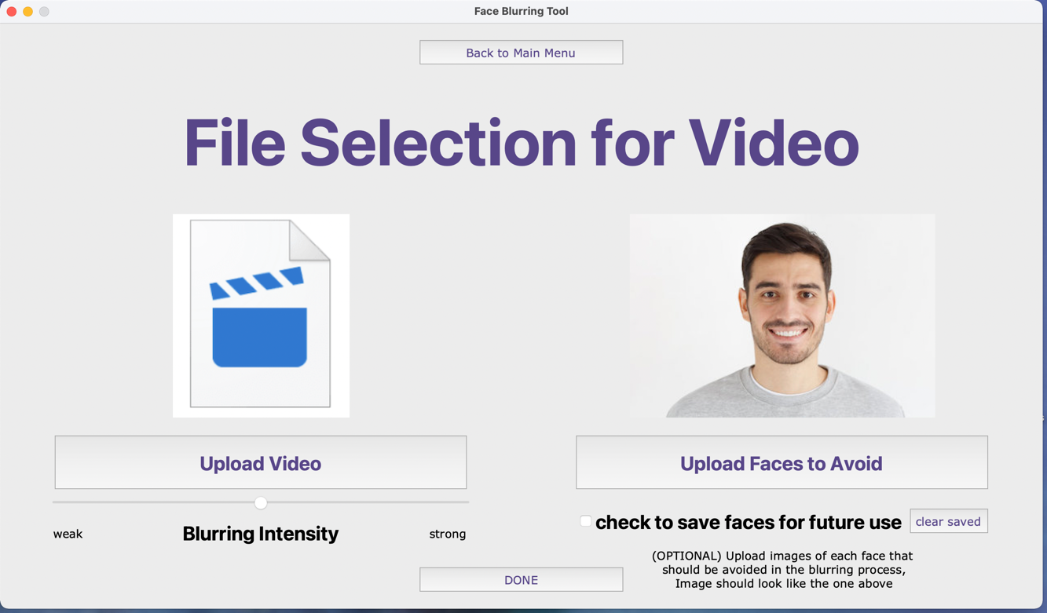

Photo Blurring button pressed on main menu

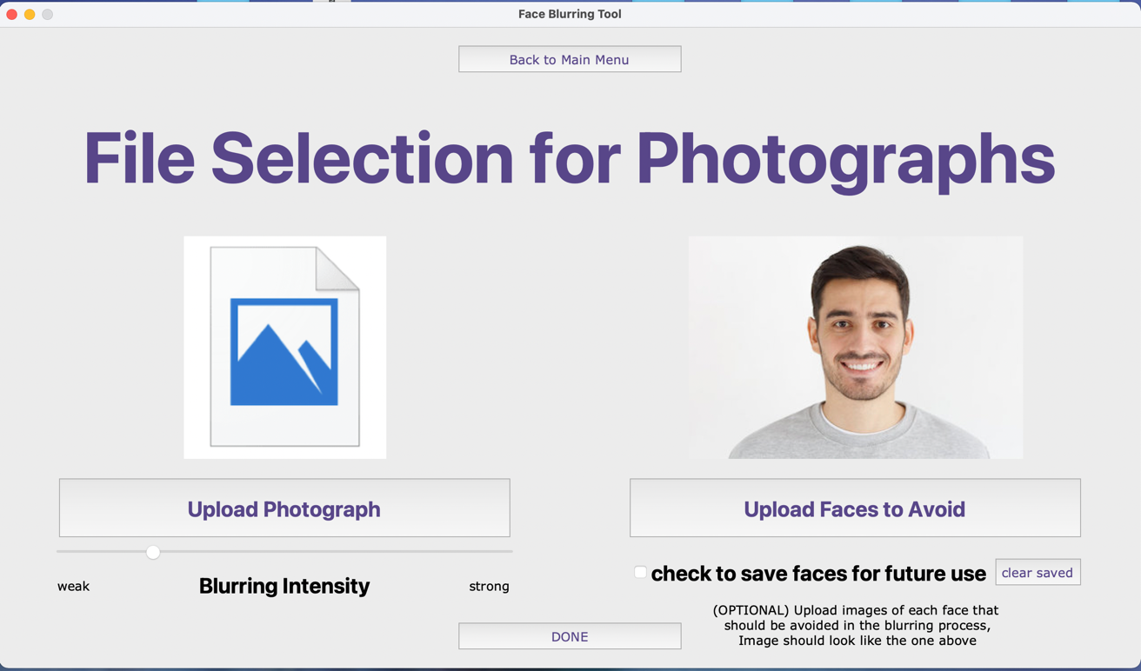

Upload face to avoid button pressed (same for videos and photos)

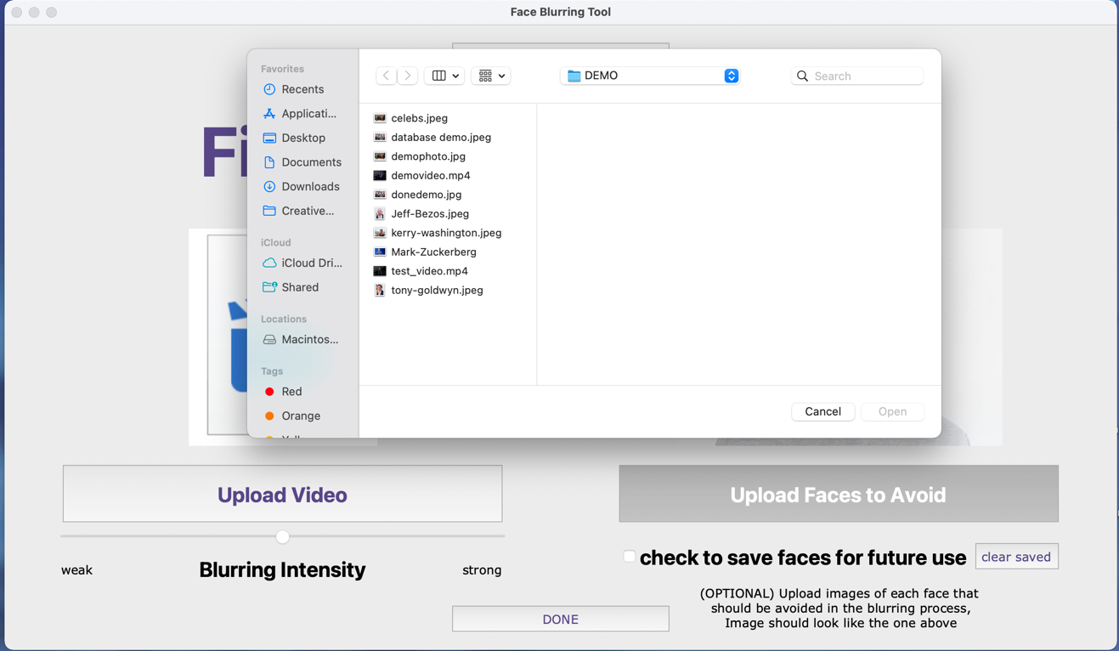

Upload video button pressed (for photos, upload photograph button has same function)

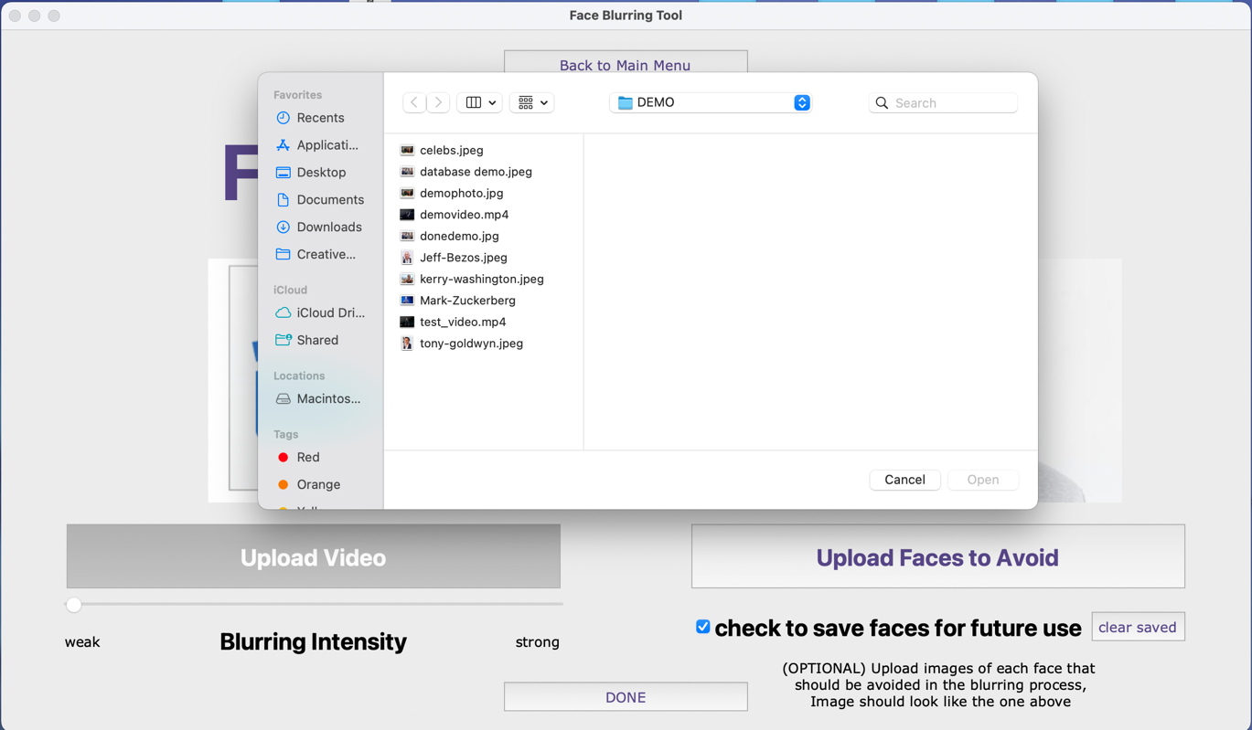

Saving image in database checkbox is ticked to save face image on database

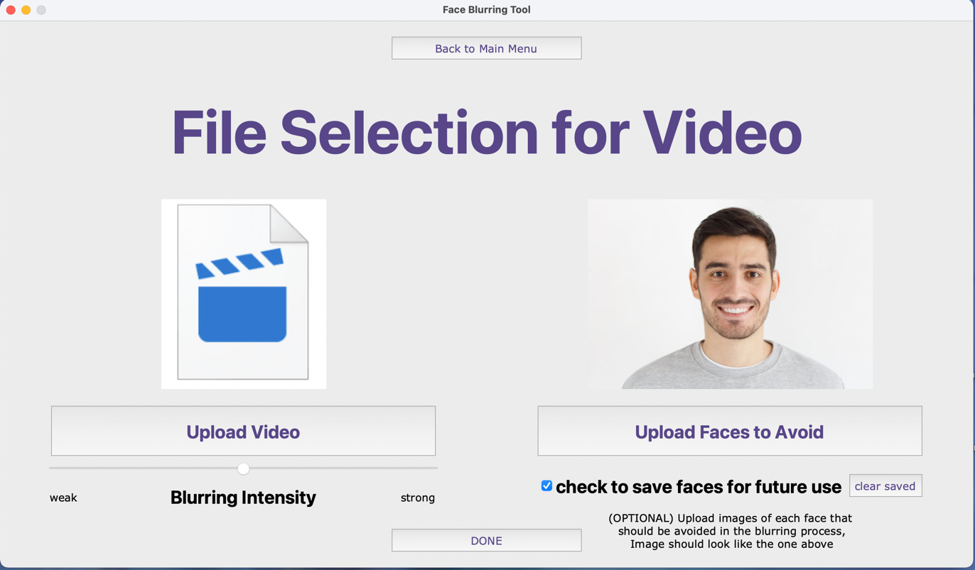

Images of faces uploaded after checkbox on database with image preview on top right (not fully visible on SQLite browser)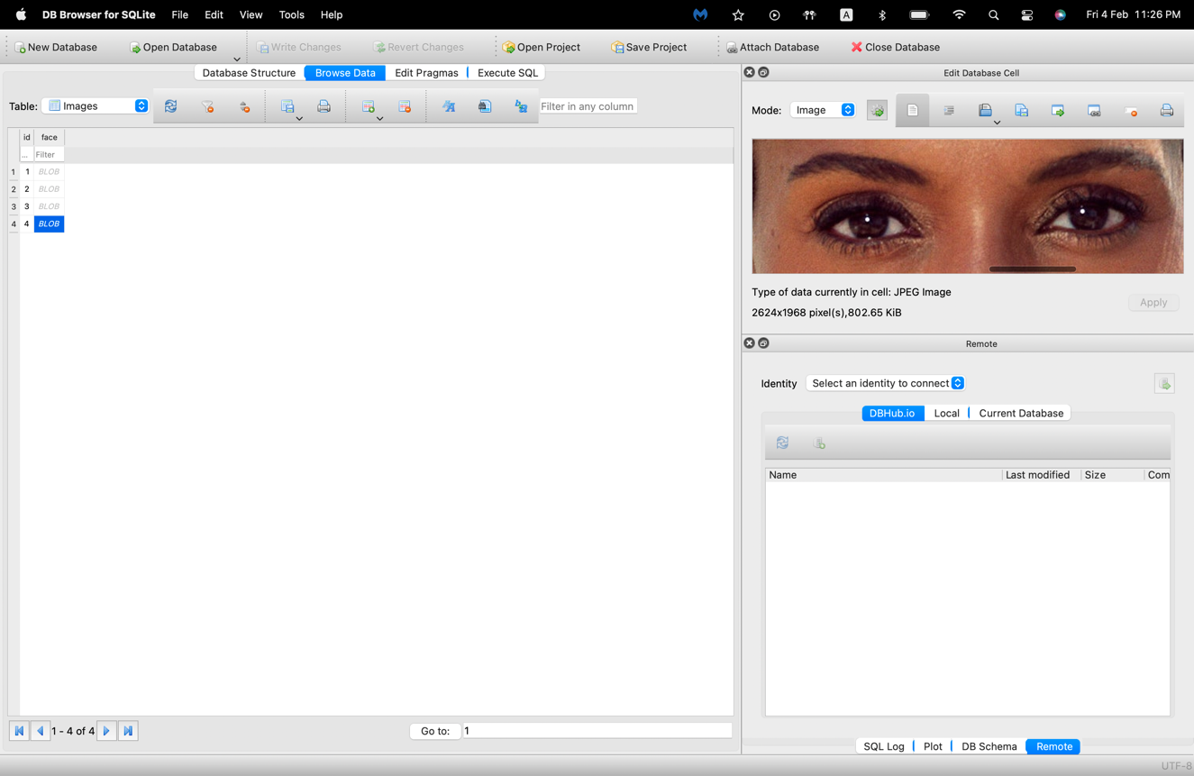

Photo preview page to view blurring result on image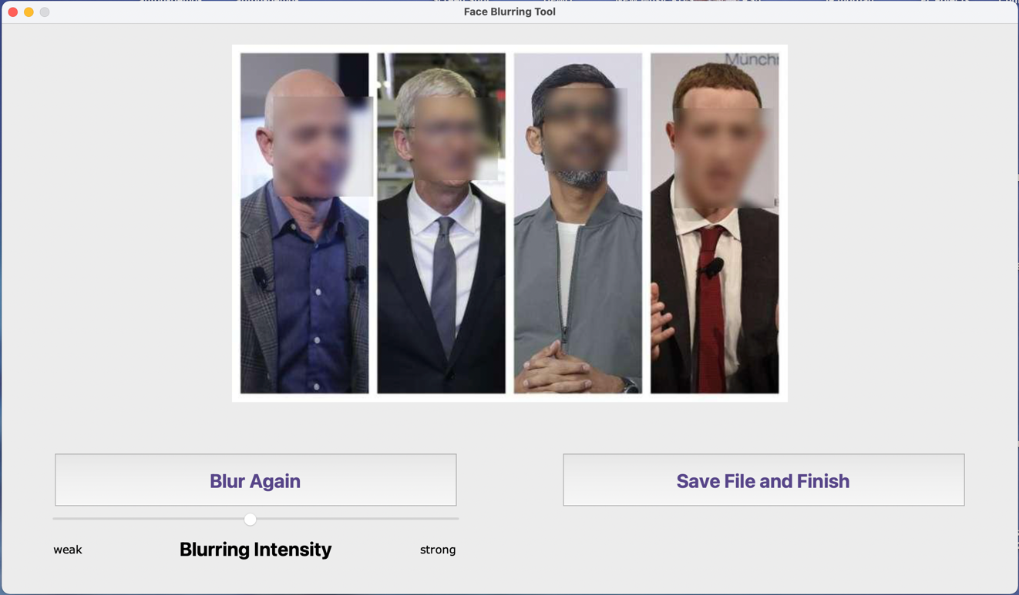

Intensity set to lowest test

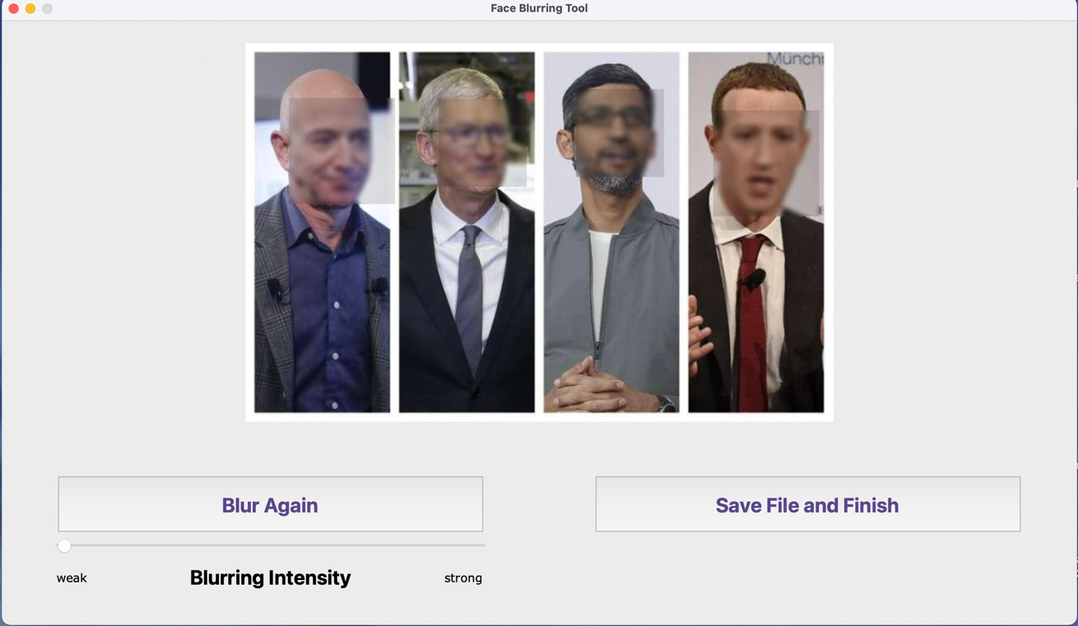

Intensity set to highest test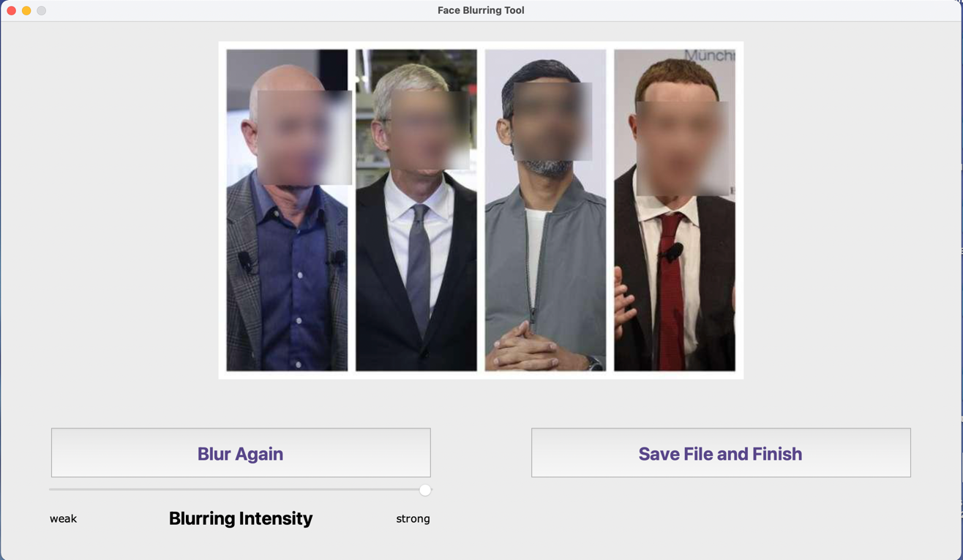

**Evaluation:**

ACHIEVED FULLY OR BETTER

PARTIALLY ACHIEVED

NOT ACHIEVED

|  |  |
| --- | --- |
| **Original objective** | **What I have achieved** |
| 1. A system has to be set in place for user to Input their photograph or video | File selection with a file searcher made within user interface |
| 1. User should be able to input pictures of faces they would like avoided in the blurring process | Face avoid section allows for several faces to be uploaded to prevent them from being blurred |
| 1. System must be put into place to adjust the strength of the blur. | Slider on GUI allows for user to adjust blurring strength before blurring, or if unhappy adjust after blurring has been complete. |
| 1. Input section has to work quickly and has to be simple to understand | Selecting input files is done instantly and effectively |
| 1. Every face in video/photo has to be blurred (except the inputted faces) | All faces are blurred in videos and images apart from the ones that are stored in the avoid file |
| 1. For videos, blurring has to be done frame by frame for accurate facial tracking | Every frame in the video is blurred separately and combined later for final blurred video |
| 1. Photo blurring process should be fast | Photo blurring is almost instant for low quality images but takes a couple seconds for high quality images |
| 1. Video blurring process should be fast | Video blurring takes around 2 times the length of the video making it slow when the videos are longer |
| 1. The user should be given a preview of what the blurred video/photo will look like | Photo preview is shown after blurring is complete however video preview section is not functioning currently. |
| 1. User should be able to decide whether they are happy with the blur | Re-blur and complete button are available in preview screen for user |
| 1. If not, blurring process has to be restarted | Re-blur and complete button are available in preview screen for user |
| 1. Once successful, video or photograph should be saved | Complete button allows user to save blurred image |
| 1. Output should be of the same file type as the user has inputted | Photo files saved as a jpeg and video files are saved as MP4 as they work on all operating systems |
| 1. System has to make it clear to user where final file will be saved, or user has to be given the option of choosing file location. | User gets to choose file location for final file to be saved and file name |

**Conclusive thoughts:**

Although I have achieved the majority of my targets there are many improvements I could implement if I were to do a similar project again.

Firstly, using python significantly hindered the speed of blurring due to python using an interpreter to execute code line-by-line making recursive functions slow. In the current system I chose to use MATLAB to reduce speed of blurring importing my code from MATLAB to python using the inbuilt engine with the gaussian blur calculations fully done and applied to images on MATLAB. This required me to learn how to use MATLAB and implement it with my already made python code. If I ever did a project with image blurring again, I would use a lower-level language which executes using a compiler such as C++ or C# as those would allow for the whole program to be coded on one language with much faster execution times.

Second, my program often has difficulties blurring faces which are from side view or very large angle to the camera so if I did a facial detection algorithm again, I would consider implementing several Haarcascade files to allow the image detection algorithm to detect any angle of the face.

Another thing I would consider if I were to do a facial blurring tool is to try and implement the system into a webpage for the convenience to users as users wouldn’t need to download or setup anything and simply upload their images online to be blurred.